Bug Description
Critical cybersecurity vulnerability (Cryptographic Failures) that are stored in plain text is listed in the OWASP Top 10 as number 2. In case a system stores passwords in their exact form as typed in by the user, any breach of the database will give all the credentials of the users at once without the need of any additional effort on the side of the attacker. This is among the worst errors that a developer can commit since it endangers all users at the same time.
How the Bug Was Identified
This activity was done by creating a simulated user registration system in Python. The weak one saved the password in a dictionary without transformation:
users_db["alice"] = "mypassword123"
Should an attacker gain access to this database by either using SQL injection, insider threat or server breach, all usernames and passwords would be displayed in readable form in real time. Users are likely to use the same password in various platforms thus this vulnerability spreads to email, banking, and the social media accounts takeovers.
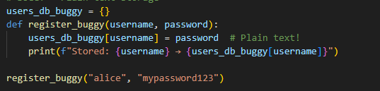
How the Bug Was Fixed
The fix consisted of hash passwords with SHA-256, a cryptographic hash algorithm of the built-in hashlib library of Python. The system now stores the hash of the raw password, rather than storing the raw password.
hashed = hashlib.sha256(password.encode()).hexdigest()
users_db["alice"] = hashed # e3b89f3c...
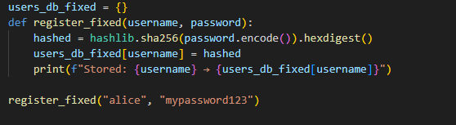
Hashing is a one-to-one map, or rather, a one-way operation, that is, it is computationally infeasible to reverse the hash to the original password. The password entered during the logging in process is hashed once again, and the hashes are compared to the one stored in a place, therefore the original password is not stored anywhere.
Conclusion
The storing of passwords with plain text is a severe vulnerability that exposes all the users to instant danger in case of any breach of the data. SHA-256 hashing is used to store passwords in an unreadable and irretrievable format. It is a best practice towards security suggested by OWASP and implemented in all modern authentication systems.

